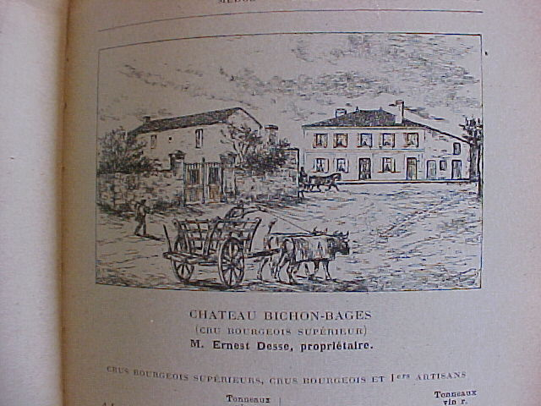

Chateau Bichon-Bages 1923 – Pauillac Cru Bourgeois Superieur – 495,00 euro

The vineyard of Chateau Bichon-Bages was located between several Cru Classe Chateaux such as Chateau Batailly, Chateau Pontet-Canet and Chateau Lynch-Bages. It was one of the oldest estates of the commune and produced a much appreciated wine in those days. It belonged to M. Ernest Desse, ‘ancien maire’ (mayor) of the village Pauillac. The production was 60 tonneaux (1 tonneau = 4 barriques of 225 liters) an equivalent of 60 x 900 liters = 54.000 liters. About 70.000 bottles a year, a considerably large production. So export would have been a necessity.

Source: CH. Cocks et Ed. Feret - Bordeaux et ses Vins 9e edition 1922
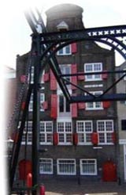

The label on this bottle says ‘expedie en barrique par Freres & Riout. According the capsule it is imported by J. van Oldenborgh (founded 1799) located in Dordrecht, one of the oldest cities of trade in the Netherlands (see picture above).

